VCS TASK

https://docs.google.com/document/d/1lCNGiRzWSPx-_gBj7knKzhBfdGPrjj6l_AphHx_Z_qI/edit?tab=t.0

Establish a new directory, populate it with script files, initiate an empty repository on GitHub, convert the local directory into a Git repository, and link it to GitHub for pushing the code into the repository.

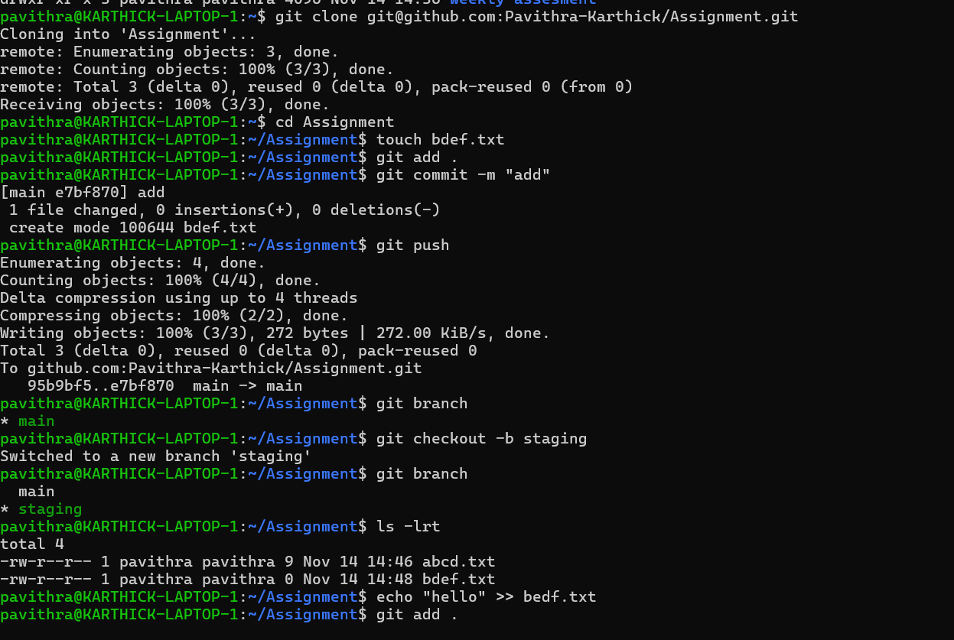

Merge , rebase and stash.
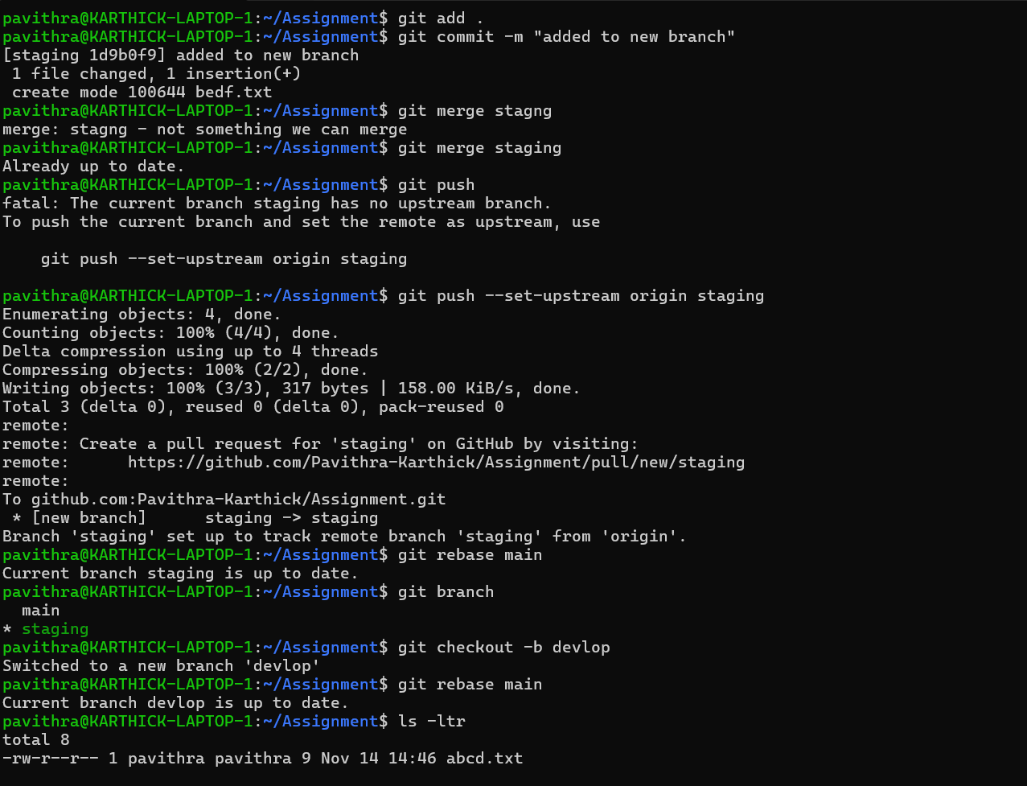

Rebase:

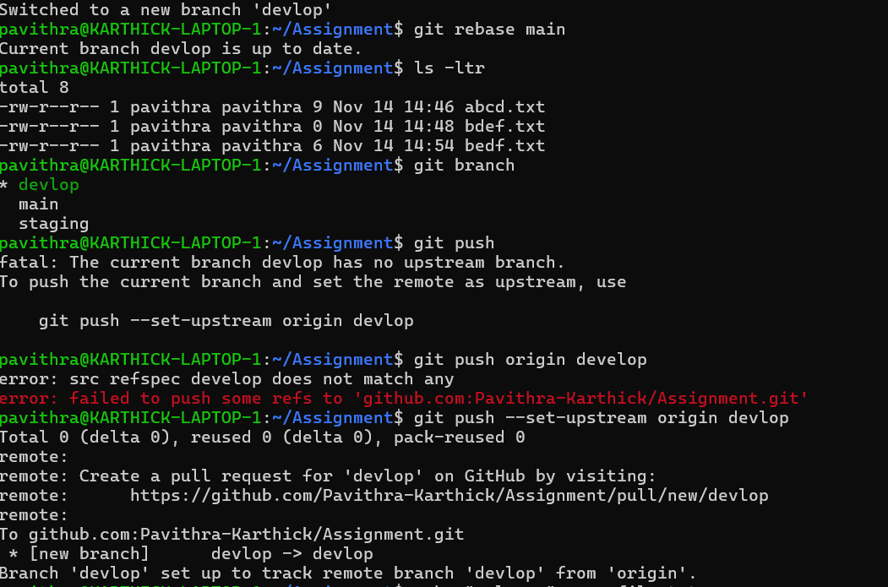
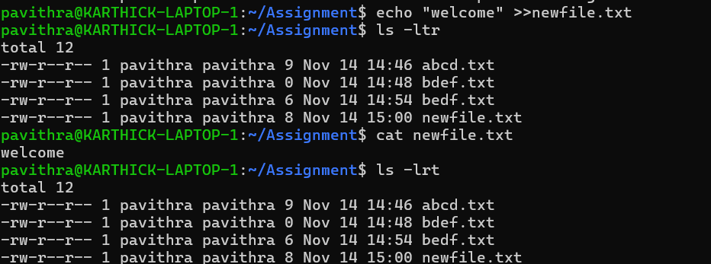
Git stash:
